New Member Project Design Report
New Member Process - Electronics

Aaryan Karnik, Raymond Yung, Daniel Macareno-Muñoz, Maisha Takahashi
October 18, 2026

Contents

- Revision Log 2
- Purpose 2
- Parties Involved 2
- Design Overview 3
4.1 Block Diagram 3
4.2 Explanation 3
- Design choices and Justification 4
5.1 Parts Given 4
5.2 Parts Chosen 4
- Schematic 5
- Firmware 5

1 Revision Log

Editor | Date | Revision #
Aaryan Karnik | 10/18/2026 | 1
Raymond Yung | 10/18/2026 | 2

2 Purpose
Design a system to read analog signals from an array of temperature sensors and convert them to digital signals, reporting them over I2C bus and indicating a fault with a status LED.

3 Parties Involved

Name | Role | Report Role
Aaryan Karnik | Team Member | Author
Raymond Yung | Team Member | Author
Daniel Macareno-Muñoz | Team Member | Author
Maisha Takahashi | Team Member | Author

4 Design Overview

4.1 Block Diagram
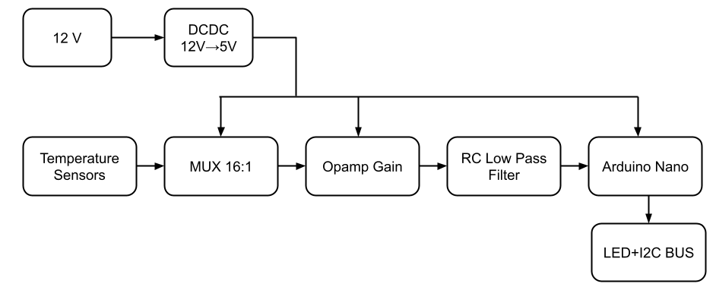
4.2 Explanation
We receive the 12V Input and feed it into the DC-DC converter which steps down the voltage into 5V, which is used by all the components used in our design. Second, this provides power to all of the components including the multiplexer, all the signal conditioning components, and the Arduino Nano. The temperature sensors all feed into the multiplexer, which receives a select input from the Arduino Nano which tells the MUX which sensor to read, which then travels through signal conditioning (gain and low pass filter), and is finally read by the Arduino Nano. The Arduino finds the max temperature and turns on the red LED if it is above 60 C. The I2C output gives information about the temperatures to any connected device.

5 Design choices and Justification
5.1 Parts Given
- Multiplexer
- Temperature sensors
- Arduino Nano
- LED

5.2 Parts Chosen
- DCDC converter - R-78E5.0-0.5
  - This part has a switching-regulator design with efficiency of up to 91%, this removes the need for heat dissipation thus, reducing unnecessary complexity.
  - This part provides a stable 5V output from an input of about 12V, which fits our specifications.
  - This converter includes short circuit protection, which protects the entire system from failure if a short circuit were to occur.
- Op Amp - MCP6002T-E/SN
  - The input voltage for this part is 1.8V-6V, and since we already have a 5V rail, we don't need a separate power supply.
  - This amp supports rail-to-rail inputs and outputs, and since we want to try to maximize our accuracy, getting close to the 5v ceiling for the arduino nano is important. It supports our amplification of 1.82, giving us an output of approximately 2.37V-4.44V.
  - This amp supports bandwidth up to 1MHz, which allows us to aim for our target of 1000Hz since it would need to run at at least 16,000 Hz to sample all sensors
- RC low pass filter - Capacitor: 4.7 uF, Resistor: 1 kiloohm
  - An RC low pass filter reduces high frequencies, so voltage that is jumping around fast, better known as noise, is filtered out and a stable and reliable reading is given to the arduino.
  - We chose a 1 kiloohm resistor and a 4.7 uF capacitor because it uses a cutoff frequency of 34 Hz, which lets stable voltage pass while reducing fast fluctuations.

6 Schematic
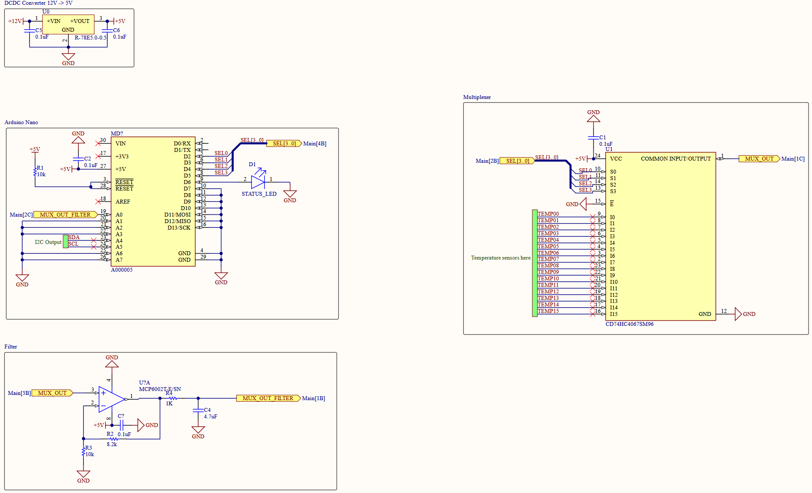
This schematic includes the Arduino nano, the multiplexer, 16 temp sensors, a DC-DC converter and signal conditioning including an opamp and RC low pass filter.

7 Firmware Skeleton
#ifndef FIRMWARE_OUTLINE_H
#define FIRMWARE_OUTLINE_H

#define NUM_TEMP_SENSORS 16
#define FAULT_THRESHOLD_C 60.0f

void initialize_peripherals(void);
void select_channel(int channel);
int read_adc(void);
float adc_to_voltage(int reading);
float voltage_to_temperature(float voltage);
void scan_temperatures(float temperatures[NUM_TEMP_SENSORS]);
float max_temperature(const float temperatures[NUM_TEMP_SENSORS]);
void update_fault_led(float maximum);
void report_i2c(const float temperatures[NUM_TEMP_SENSORS], float maximum);

#endif

